**Day-5 Assignment**

Create a PPT of any one topic from your teaching subject using SlidesGPT or Gamma, and share link/PDF.

**Step 1: Sign Up / Login**

1. Open <https://gamma.app>.
2. Sign up with **Google account / Email** (free plan is enough).



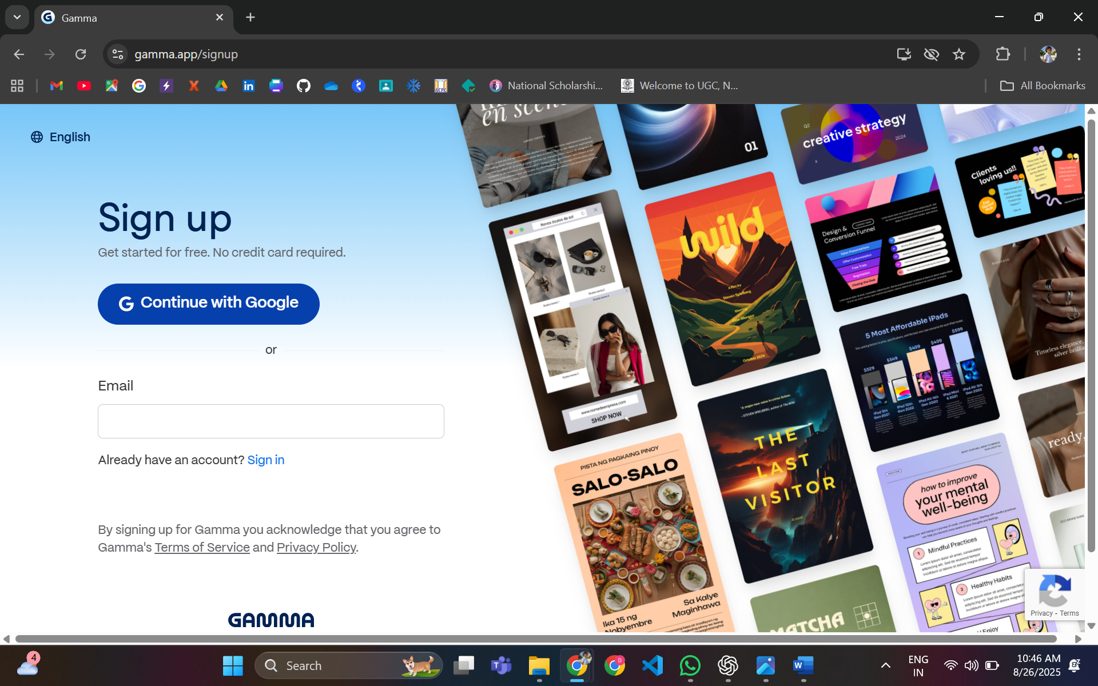

**Step 2: Start a New Presentation**

1. On dashboard → Click **“+ Create”** → Select **“Presentation”**.
2. Gamma will open a **prompt box** where you can type your topic.

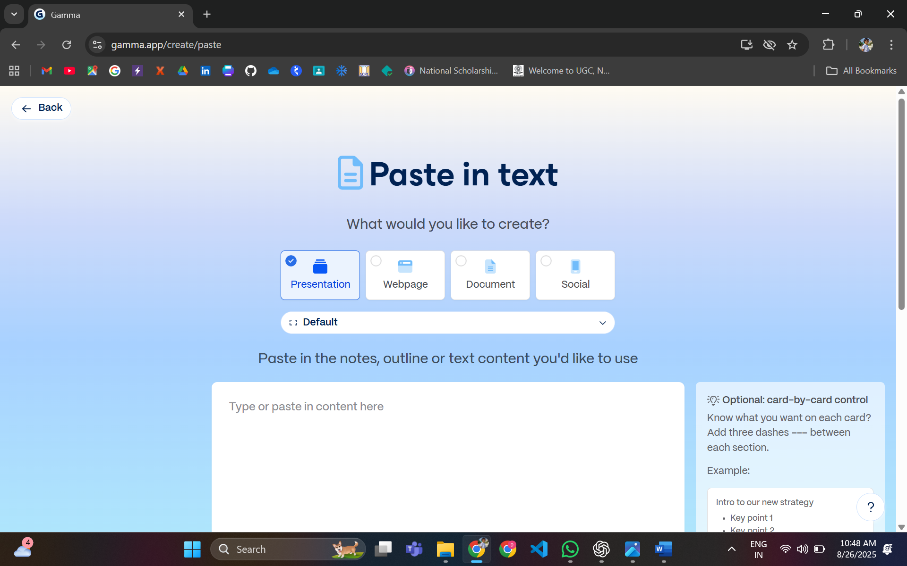

**Step 3: Enter Prompt (Your Topic)**

* Type: *“Create a presentation on [your subject topic] for students. Include an introduction, key concepts, examples, and conclusion. Keep design professional and academic.”*
* Example: *“Create a 7-slide presentation on the topic ‘Introduction to Artificial Intelligence’ for engineering students.”*

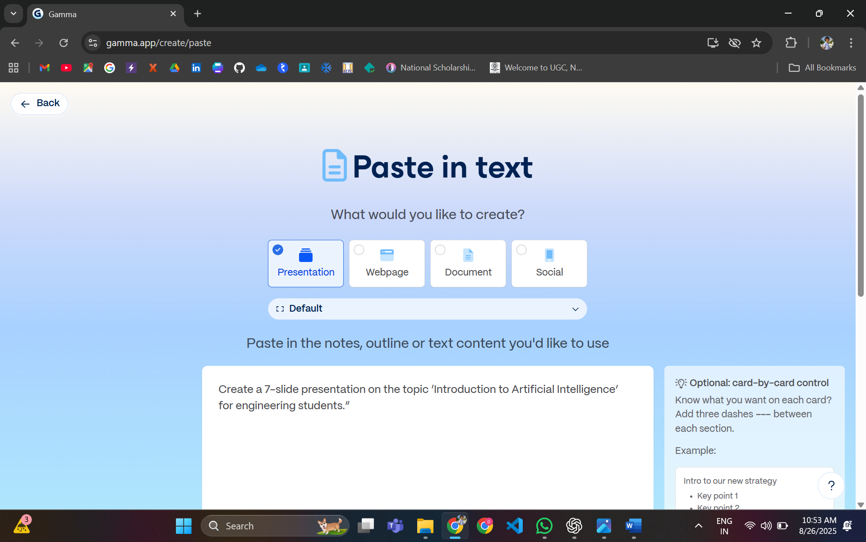

**Step 4: Customize the Design**

1. Gamma will generate slides automatically.
2. Choose a **design theme** (minimal, colourful, professional).
3. Adjust font, images, or layout if needed.

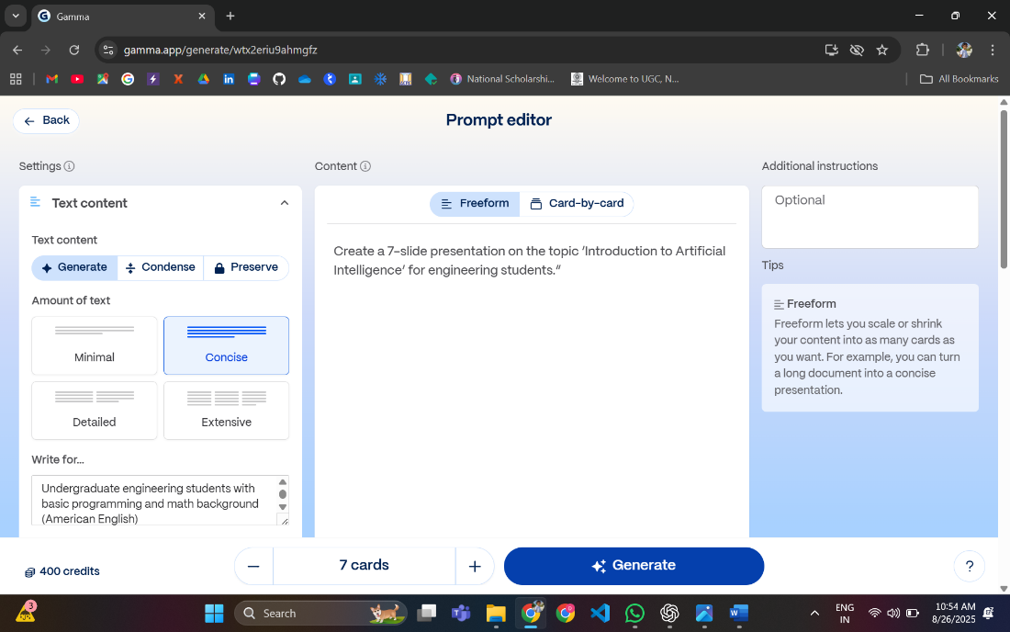

**Step 5: Edit & Refine Content**

* Review each slide → Add/edit text if required.
* Replace any AI-generated example with your own subject-specific notes.
* You can also insert **charts, tables, or icons** directly inside Gamma.

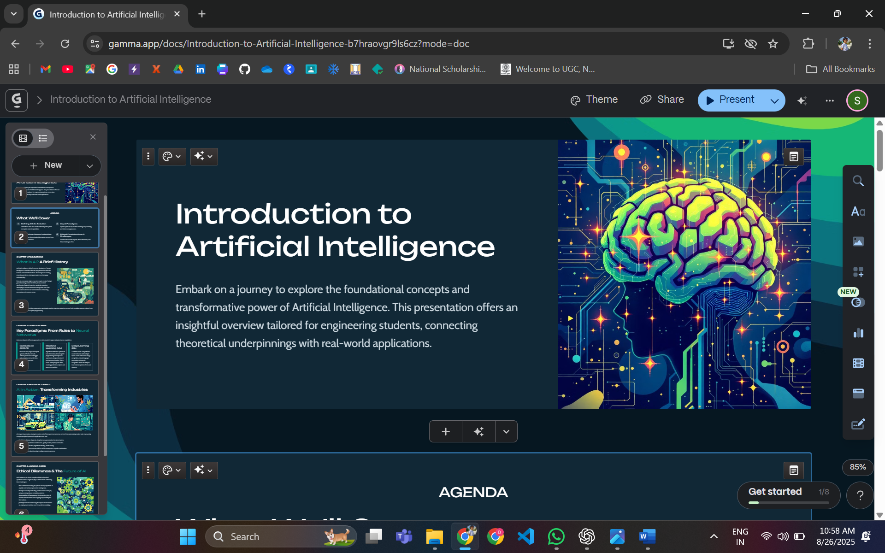

**Step 6: Export / Share**

1. Click **Share → Copy Link** (to share online).
2. Or **Export as PDF** → Save file.
3. Submit link/PDF as required in the task.

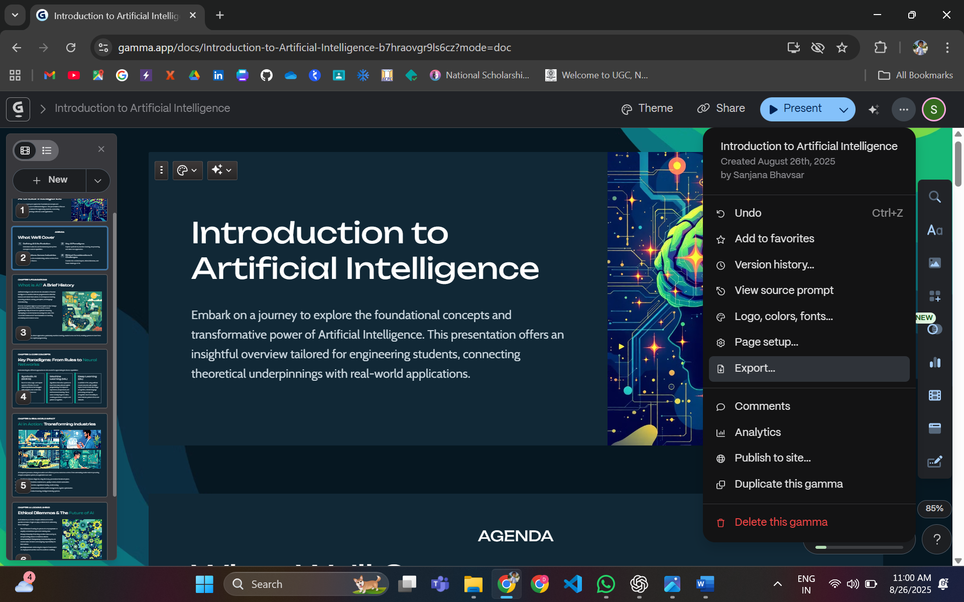

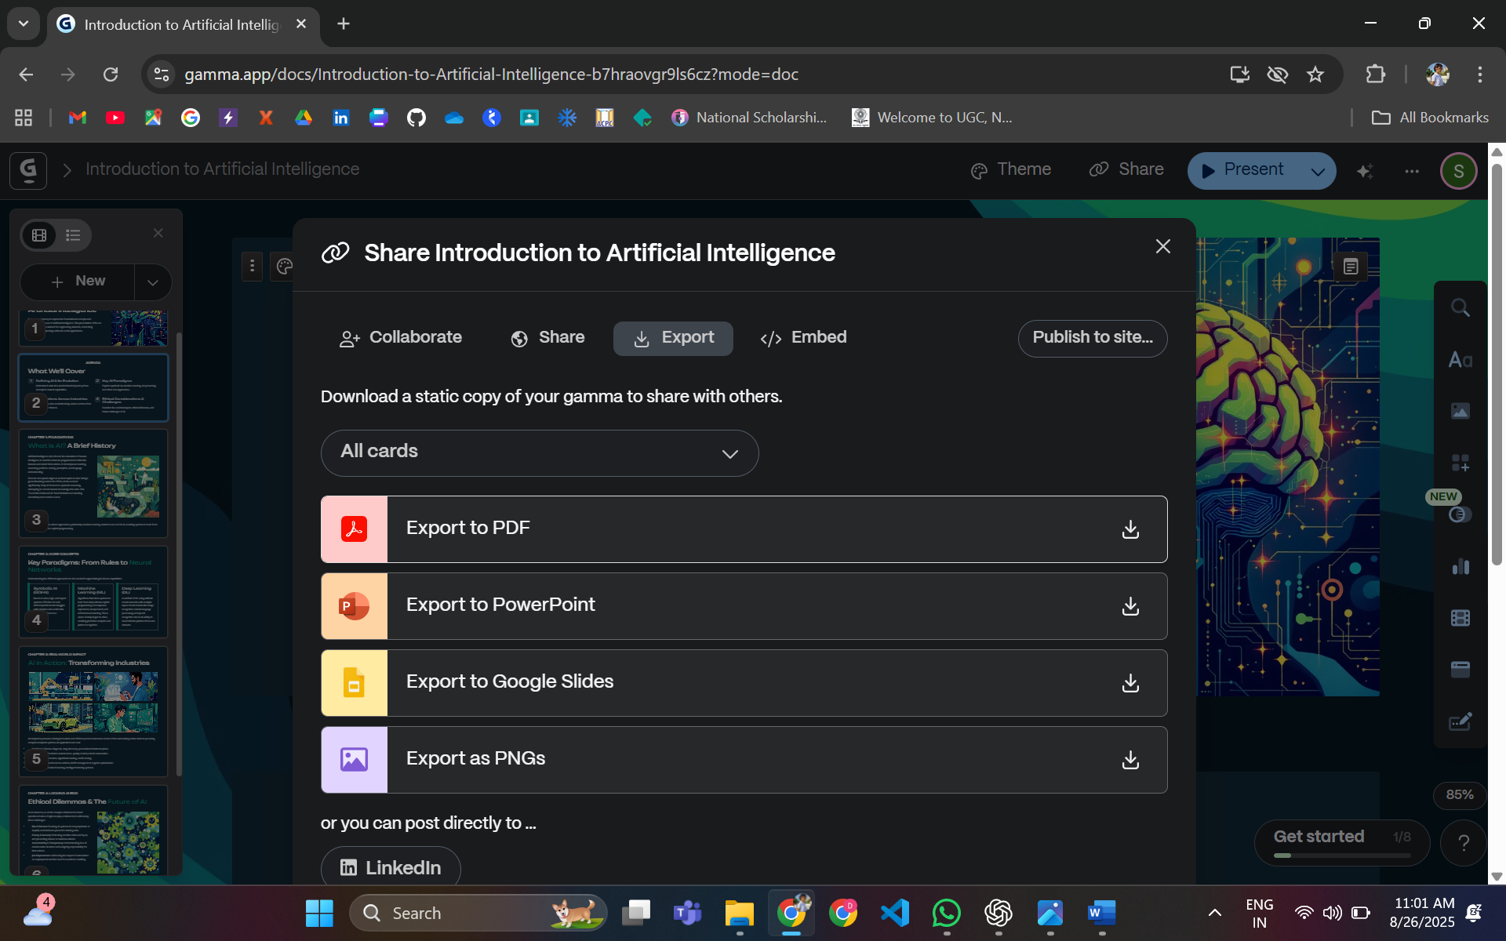

**📌 Sample Topic for Implementation in Gamma**

To practice, you can use a **common academic topic** like:

* **“The Importance of Renewable Energy in Today’s World”**
* **“Basics of Artificial Intelligence”**
* **“Time Management Skills for Students”**
* **“Introduction to Cloud Computing”**
* **“Cybersecurity Awareness for Beginners”**